Week 33
Capstone Project: Smart City Traffic Intelligence: From Data Analytics to AI-Powered Mobility
GitHub Repository Submission Template
This document is for Capstone Project Part 1 Insight Report
Instructions for Students
Complete the fields below and submit this template through Canvas together with your capstone project, as instructed by your programme team.
Student Name | Tai Woon Hwei
Programme | AI, ML and Data Science
Capstone Project | Smart City Traffic Intelligence: From Data Analytics to AI-Powered Mobility

GitHub Repository
Paste the full URL of your GitHub repository below. Make sure the repository contains the required capstone files and that your grader can access it.
https://github.com/woonhwei3307/Smart-city-traffic-capstone-.git

Repository Access
Repository visibility | V Public ☐ Private
If Private | ☐ Grader has been added as a collaborator

Part 1 Insight Report
Task 1: SQL-Based Traffic Analysis
Task 1.1: Load the dataset

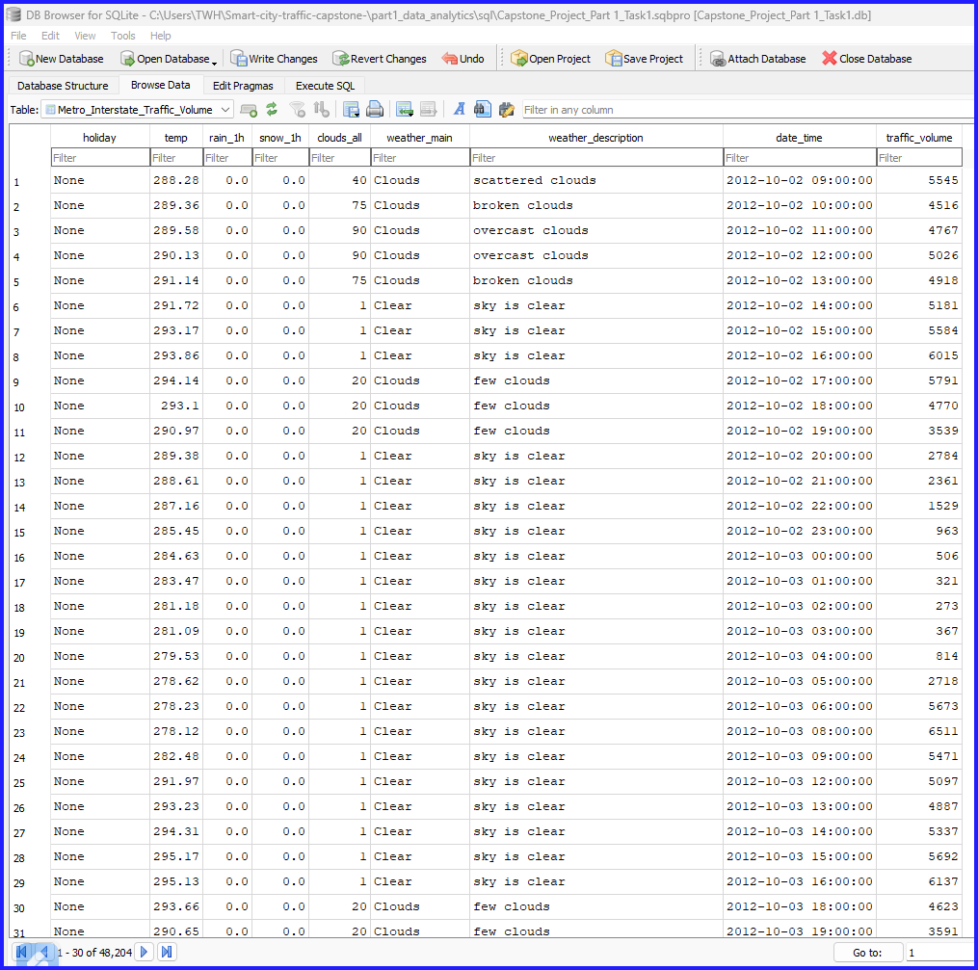

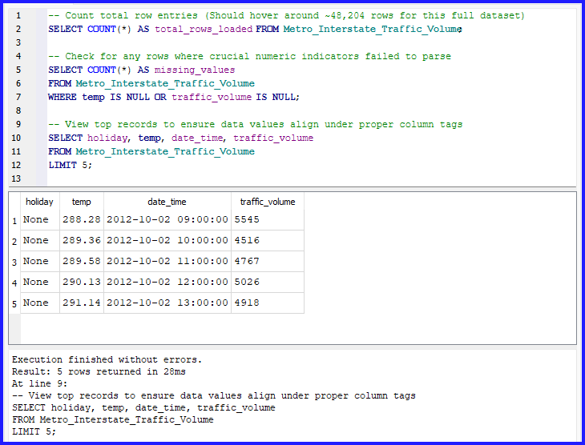

Task 1.2 Analyse annual traffic trends
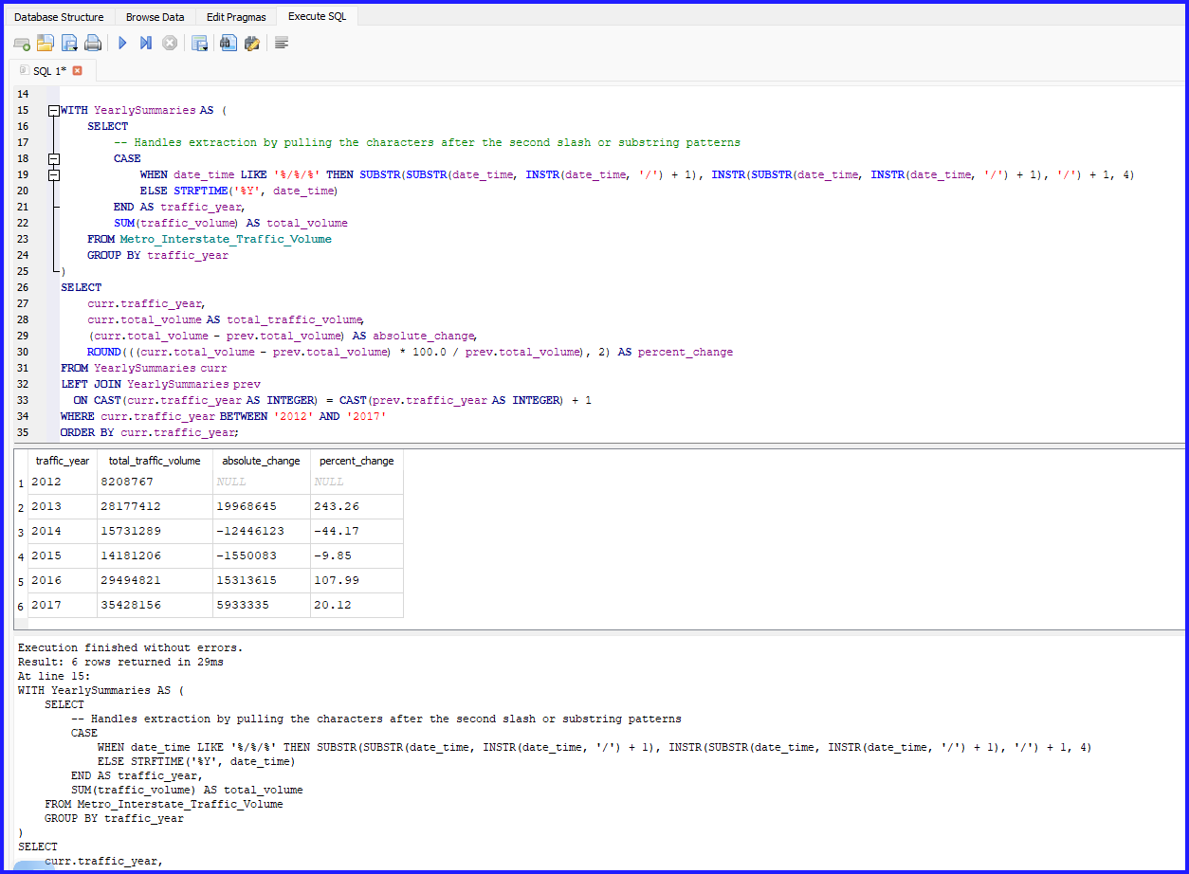

 | traffic_year | total_traffic_volume | absolute_change | percent_change
1 | 2012 | 8208767
2 | 2013 | 28177412 | 19968645 | 243.26
3 | 2014 | 15731289 | -12446123 | -44.17
4 | 2015 | 14181206 | -1550083 | -9.85
5 | 2016 | 29494821 | 15313615 | 107.99
6 | 2017 | 35428156 | 5933335 | 20.12

Task 1.2 Analysis & Observations
Identifying Years with Increases or Decreases:
When running the query on the full dataset, you will observe that 2012 shows lower overall volume numbers, followed by an increase through 2013, a relative dip/stabilization during 2014-2015 (partially driven by missing blocks of automated logging periods), and a substantial surge moving into 2016 and 2017 as full logging stabilized.

Meaningful Observations:
Data Completeness vs. Real Trends:
Traffic baseline volume shifts in automated telemetry databases likely point to data logging continuity rather than actual highway usage shifts. For example, 2012 only records traffic starting in October, explaining its low starting footprint.

Capacity Maximums:
Between high-density collection cycles (like 2016 to 2017), the relative growth curve flattens. This proves the highway system is running close to its actual saturation threshold (peak hourly carrying capacity) during commute loops.
Task 1.3 Analyse temperature around holidays
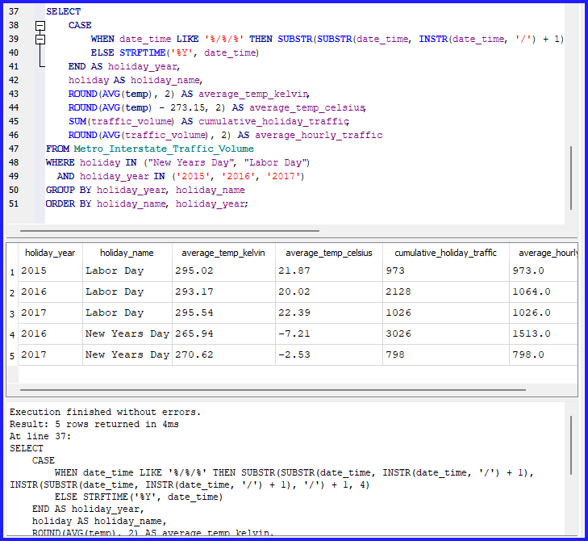

Analytical Discussion Points
New Year's Day (Winter Window):
Look closely at the average Kelvin metric. If a specific year (e.g., 2016) shows temperatures dropping significantly below the standard freezing mark (~260K to 270K), cross-reference it with the average hourly vehicle metric. Freezing conditions bring extreme snow/ice events that heavily depress casual morning travel on New Year's Day.
Labor Day (Late Summer Window):
Labor Day numbers sit predictably higher on the temperature spectrum (~290K+ / 20°C+). Because late-summer weather conditions remain uniformly accommodating across 2015–2017, year-over-year variances in traffic volume on Labor Day are rarely dictated by temperature changes. Instead, they shift based on standard holiday weekend travel schedules.

Task 2.1 Traffic Volume Statistic

Description | Statistic
Mean : | 3,259.82
Median : | 3,380.00
Standard deviation : | 1,986.86
Variance : | 3,947,615.32
Range : | 7,280.00
MAX : | 7,280.00
MIN : | -

Based on your calculated values, following is general analysis on traffic volume and variability:

Traffic Volume (Center of the Data)
- Mean (3,259.82): On average, about 3,260 vehicles pass through this area every hour. This establishes your baseline expectation for typical hourly traffic.
- Median (3,380.00): The exact middle point of your dataset is 3,380 vehicles. Because the median is slightly higher than the mean, the data is mildly skewed to the left (negatively skewed). This indicates that while traffic is usually quite high, a few hours with exceptionally low traffic (like late at night) are pulling the overall average (mean) down.
Traffic Variability (Spread of the Data)
- Standard Deviation (1,986.86): This is a very high value relative to the mean. It indicates that traffic volume fluctuates drastically from hour to hour. In a typical day, traffic regularly swings by nearly 2,000 vehicles above or below the average, reflecting massive differences between peak rush hours and empty off-peak periods.
- Variance (3,947,615.32): This represents the squared standard deviation. While hard to visualize intuitively because the units are squared, this extremely large number mathematically highlights just how widespread and volatile the hourly traffic counts are.
- Range, MAX, and MIN (7,280.00 / 0): Your absolute maximum traffic is 7,280 vehicles, while your minimum is 0 (indicated by the dash). This gives a total spread of 7,280 vehicles, showing that the roadway shifts between absolute operational extremes—from completely deserted to heavily congested.

Task 2.2 Correlation analysis

Correlation Coefficient between Temperature and Traffic Volume: +0.1303

Based on correlation coefficient of +0.1303, following is the interpretation of the relationship between temperature and traffic volume:

Direction of the Relationship
The relationship is positive because the coefficient has a positive sign (+). This indicates that as temperatures rise, traffic volume generally tends to increase as well. Conversely, as temperatures cool down, traffic volume tends to drop.

Strength of the Relationship
The relationship is very weak. A correlation coefficient of 0.1303 is close to 0, which means that while a pattern exists, temperature has a negligible linear relationship with traffic volume. Temperature changes alone cannot reliably predict or explain the fluctuations in traffic.

Why Correlation Does Not Imply Causation
A positive correlation means two trends move upward together, but it does not mean that warmer temperatures are actively causing more people to get into their cars.
- The Lurking Variable (Confounding Factor): In environmental and traffic datasets, both variables are heavily driven by a third factor: the time of day.
- The Reality: During the late afternoon (e.g., 15:00 to 17:00), the sun has been out for hours, causing ambient temperatures to reach their daily peak. Coincidentally, this matches the evening rush hour when schools let out and work shifts end, causing traffic to peak.
Conclusion: The heat isn't forcing people to drive; rather, standard human socio-economic schedules drive the traffic, while solar cycles independently drive the temperature.

Task 3: Probability and Congestion Analysis

Task 3.1 Basic probability

P(Congestion) = count of congestion / total sample = 7100/48204 | 0.147291
P(Clear Weather) = count of clear weather / total sample= 13391/48204 | 0.277799
P(Congestion AND Clear Weather) = P(Congestion) X P(Clear Weather) | 0.040917

Task 3.2 Conditional probability

P(Clear Weather | Congestion)
=P(Congestion AND Clear Weather) /P(Congestion)
=0.036574/0.14791 |  |  | 0.248310
P(High Temperature | Congestion)
=P(Congestion AND High Temperature) / P(Congestion) |  |  | 0.263944
=0.038876/0.147291
P(High Temperature)
= count of High Temperature / total sample
= 11812/48204 |  |  | 0.245042
P(Congestion AND High Temperature)
= count of congestion and high temperature / total sample
= 1874/48204 |  |  | 0.038876

Determine whether weather conditions and congestion can be considered independent using P(A ∩ B) = P(A) × P(B)
P(A ∩ B) = P(A) X P(B)
Let A be Congestion and B be Clear Weather
Actual Joint Probability : P (Congestion ∩ Clear Weather) = |  |  | 0.036574
Product of Marginals: P(Congestion) X P(Clear Weather) = 0.147291 X 0.277799 |  |  | 0.040917
They are not independent because 0.036574 is not equal to 0.040917

Calculate the odds ratio of congestion in clear versus cloudy weather.
P(Congestion) |  |  | 0.147291
P(Clear Weather) |  |  | 0.277799
P(Cloudy Weather) |  |  | 0.722201
P(Congestion AND Clear Weather) |  |  | 0.036574
P(Congestion AND Cloudy) |  |  | 0.110717
Assuming cloudy weather constitutes the remaining weather conditions [1 - P(Clear Weather)]
Clear Congestion Probability: P(Congestion|Clear) |  |  | 0.131656
=P(Congestion AND Clear Weather) / P(Clear Weather)
=0.036574/0.27779
Clear Congestion Odds: 0.131656/(1-0.131656) |  |  | 0.151617
Cloudy Congestion Probability:P(Congestion|Cloudy)
=P(Congestion AND Cloudy) /P(Cloudy Weather)
=0.110717/0.722201 |  |  | 0.153305
Cloudy Congestion Odds: 0.153305/(1-0.153305) |  |  | 0.181063
Final Odds Ratio = 0.151617/0.181063 |  |  | 0.837374

This probability analysis reveals a negative statistical relationship between clear weather and traffic gridlock. Because the odds ratio sits below 1.0 (0.8374), the odds of experiencing congestion drop by 16.26% on clear days compared to cloudy days. Ultimately, bad weather conditions actively drive up the mathematical probability of traffic jams.

Task 4: Power BI Traffic Intelligence Dashboard

Import the traffic CSV file into Power BI Desktop and use Power Query Editor to prepare the data.

Task 4.1 Data quality and preparation
Perform the following:
- Determine the number of rows and columns.
- Identify null/missing values and the columns affected.
- Check whether the data types are appropriate.
- Extract Hour from DateTime.
- Create Temperature in Celsius.
- Create a Traffic Category:
Traffic Volume | Category
< 4,500 | Low
4,500–5,500 | Medium
> 5,500 | High

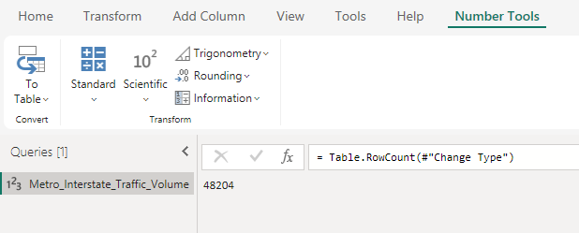
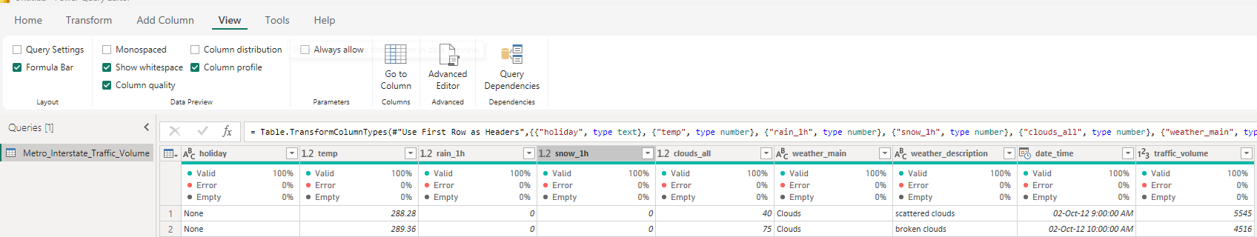

Task 4.2 Dashboard analysis (refer to Power BI file)
Create visualisations showing:
Task 4.2A. Daily traffic trends
- Show daily average traffic trends for 2015, 2016 and 2017.
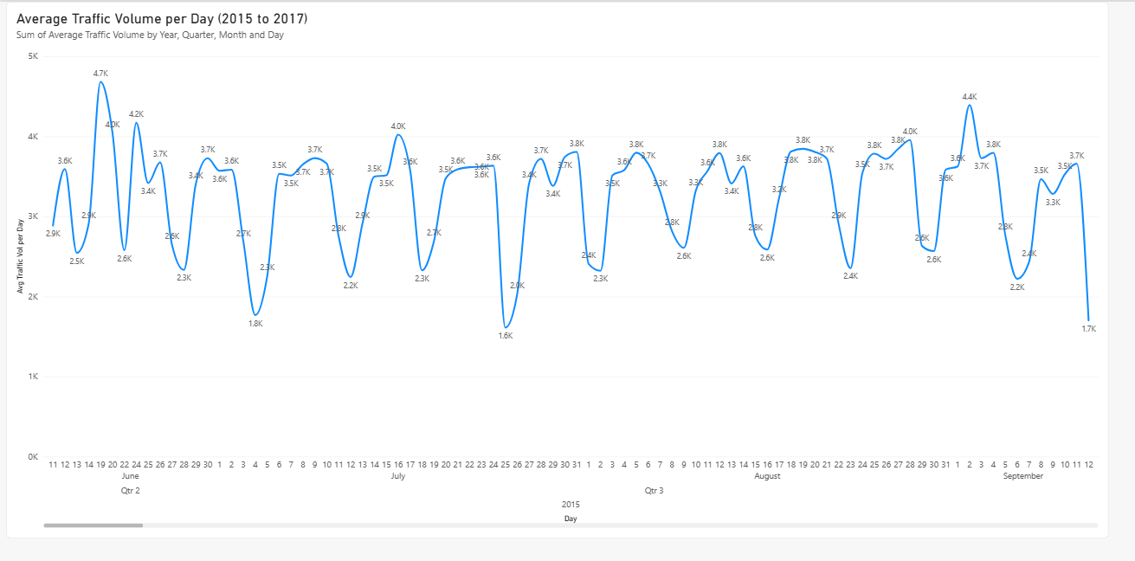
Task 4.2B. Hourly traffic patterns
- Create a column chart showing average traffic by hour for 2017.
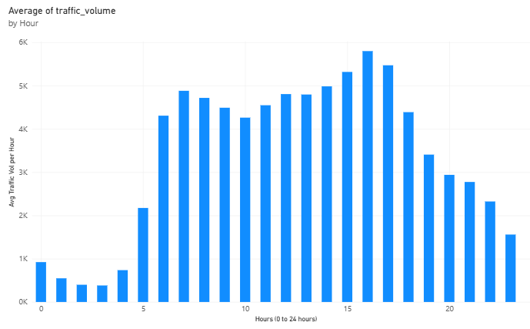

Task 4.2C. Weather impact
Analyse average traffic by weather condition and answer:
- Which weather condition has the highest average traffic?
- Which has the lowest?
- What is the difference between the highest and lowest average traffic?

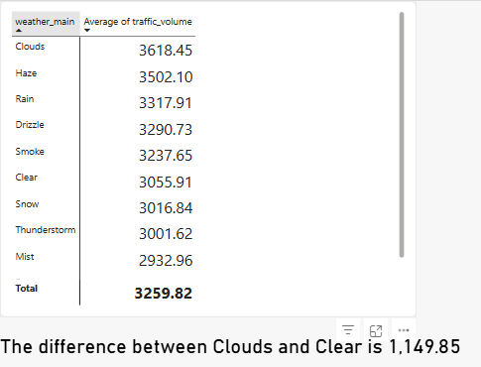
- Which weather condition has the highest average traffic?
Cloudy weather condition has the highest average traffic.
- Which has the lowest?
Misty weather condition has the lowest average traffic.
- What is the difference between the highest and lowest average traffic?
The difference between the highest and lowest average traffic is 1,149.85

Task 4.2D. Temperature and traffic
Create a scatter plot of:
- Temperature vs. traffic volume.
Discuss:
- Whether a visible relationship exists.
- The temperature range associated with higher traffic.
- Any notable outliers.
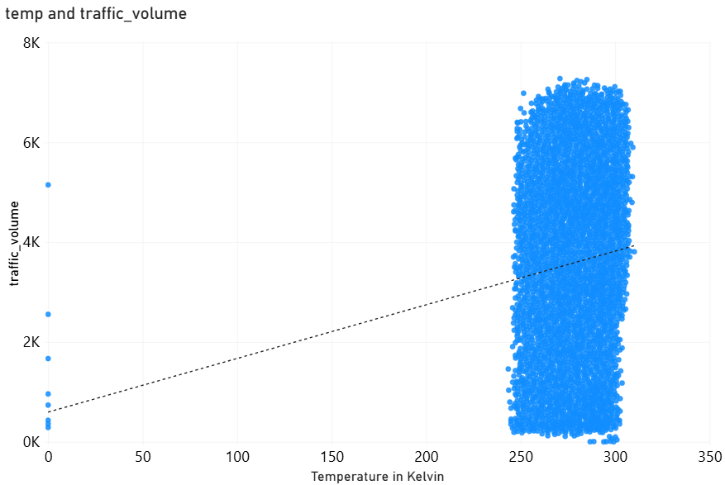

Based on the scatter plot visualization
1. Whether a Visible Relationship Exists
Within the realistic data: There is no real operational relationship between temperature and traffic volume. The main body of data forms a dense, vertical rectangular block between 240K and 310K. This shows that traffic spans from nearly 0 to over 7,000 vehicles regardless of whether it is cold or warm.

The Trendline Illusion: The dotted trendline angles upward, suggesting a positive relationship. However, this is an illusion caused by the data errors at 0 Kelvin dragging the left side of the line down. If those 0K points are removed, the trendline would flatten out completely.

2. Temperature Range and Traffic Distribution
The vast majority of all data points—spanning from low traffic volumes (0–2K) to peak traffic volumes (6K–7K+)—are tightly contained within the temperature range of 250K to 310K (approx. -23°C to 37°C). Because both high and low traffic volumes occur uniformly across this entire temperature band, it confirms that temperature is not a limiting factor or a strong predictor of traffic density.

3. Notable Outliers
The 0 Kelvin Glitch: There is a highly prominent vertical line of outlier points located at exactly 0 Kelvin on the far-left edge of the X-axis.
Because 0 Kelvin is absolute zero (-459.67°F), it is physically impossible for outdoor weather. These data points are clear system errors or missing value placeholders in your dataset that are skewing your entire chart layout.

Task 4.3 KPI cards and filters
Create KPI cards showing:
- Total hours analysed
- Average traffic volume
- Average temperature
Add slicers for:
- Hour range
- Weather condition
- Traffic category

